SUMMER TRAINING PROJECT REPORT
(Term June-July 2025)

(Pylist – A Python-like List Implementation in C++)

Submitted by

(Saurabh Yadav)
Registration Number :12310243

Course Code CSE443

Under the Guidance of

(Mr. Mukesh Sharma)

School of Computer Science and Engineering

Certificate
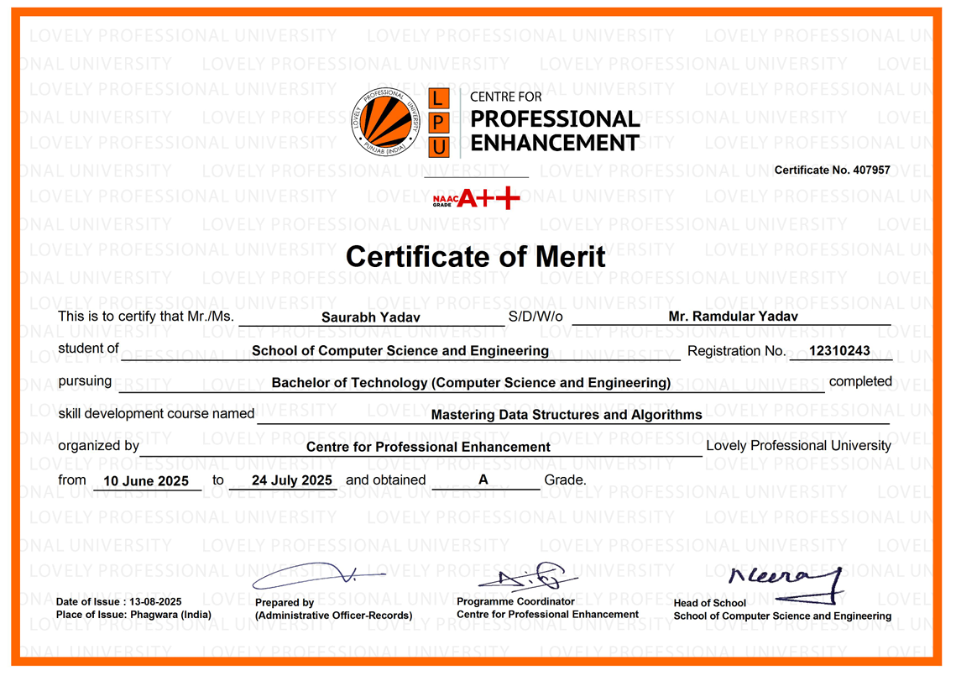

Acknowledgement
I would like to express my sincere gratitude to Mr. Mukesh Sharma for assigning this project and providing continuous guidance, mentorship, and encouragement throughout the course. His valuable insights and clarity in explaining complex concepts helped me understand and implement this project successfully.
This project, titled “Pylist: A Python-Style Multi-Type List in C++ Using Custom Data Structures”, has given me hands-on experience with object-oriented programming, dynamic memory management, and the use of advanced features like operator overloading and linked lists in C++. I am thankful for the opportunity to apply theoretical knowledge into practical implementation.
I also appreciate the structured learning approach of the course, which provided a strong foundation and inspired me to take on this challenge.
Lastly, I extend my heartfelt thanks to my family and friends for their continuous support and motivation during the project journey.

Saurabh Yadav
1231024
Table of Contents

Chapter 1: INTRODUCTION 1
1.1 COMPANY PROFILE 1
1.2 OVERVIEW OF TRAINING DOMAIN 1
1.3 OBJECTIVE OF THE PROJECT 1
CHAPTER 2: TRAINING OVERVIEW 2
2.1 TOOLS & TECHNOLOGIES USED 2
2.2 AREAS COVERED DURING TRAINING 2
2.3 DAILY / WEEKLY WORK SUMMARY 3
CHAPTER 3: PROJECT DETAILS 3
3.1 TITLE OF THE PROJECT 3
3.2 PROBLEM DEFINITION 3
3.3 SCOPE AND OBJECTIVES 4
3.4 SYSTEM REQUIREMENTS 4
3.6 DATA FLOW / UML DIAGRAMS 5
CHAPTER 4: IMPLEMENTATION 5
4.1 TOOLS USED 5
4.2 METHODOLOGY 5
4.3 MODULES / SCREENSHOTS 6
CHAPTER 5: RESULTS AND DISCUSSION 9
5.1 OUTPUT / REPORT 9
5.2 CHALLENGES FACED 9
5.3 LEARNINGS 10
CHAPTER 6: CONCLUSION 10
6.1 SUMMARY 10

Chapter 1: INTRODUCTION

1.1 COMPANY PROFILE
This project was undertaken as part of the SUMMER TRAINING PROGRAM offered by LOVELY PROFESSIONAL UNIVERSITY. The course titled "MASTERING DATA STRUCTURES AND ALGORITHMS" was guided by MR. MUKESH SHARMA, a highly experienced faculty member known for his hands-on teaching approach and strong expertise in programming.
Lovely Professional University is one of India's leading academic institutions, recognized for its industry-oriented education and strong focus on practical skills. The summer training program was designed to help students gain deep insights into core programming concepts and apply them in real-world problem-solving scenarios using C++.

1.2 OVERVIEW OF TRAINING DOMAIN
The training focused on the domain of DATA STRUCTURES AND ALGORITHMS (DSA) with an emphasis on real-world implementation using C++ programming language. The course offered in-depth understanding and application of key concepts such as:
- ARRAYS, LINKED LISTS, STACKS, AND QUEUES
- TREES, GRAPHS, AND HASHING TECHNIQUES
- SEARCHING AND SORTING ALGORITHMS
- RECURSION AND DYNAMIC PROGRAMMING
- IMPLEMENTATION OF CUSTOM DATA STRUCTURES
The training aimed to develop logical thinking, coding efficiency, and design skills through practical exercises, coding challenges, and project-based learning.

1.3 OBJECTIVE OF THE PROJECT
The primary objective of this project was to DESIGN AND IMPLEMENT A CUSTOM DATA STRUCTURE IN C++ that emulates the behavior of Python’s built-in list—which allows the storage of multiple data types in a single container.
The key goals of the project were:
- TO CREATE A MULTI-TYPE CONTAINER THAT SUPPORTS INT, FLOAT, DOUBLE, STRING, CHAR, AND BOOL
- TO IMPLEMENT A DOUBLY LINKED LIST FOR DYNAMIC MEMORY MANAGEMENT
- TO PROVIDE FUNCTIONALITIES SUCH AS APPEND, INSERT, POP, REMOVE, REVERSE, AND SLICE
- TO PRACTICE ADVANCED C++ CONCEPTS INCLUDING ENUMS, CONSTRUCTORS, DESTRUCTORS, AND OPERATOR OVERLOADING
- TO IMPROVE PROBLEM-SOLVING SKILLS BY REPLICATING A PYTHON-LIKE DATA STRUCTURE IN A STATICALLY TYPED LANGUAGE
This project provided an opportunity to bridge the gap between theory and practice, strengthening the understanding of memory management, object-oriented design, and data structure customization.

CHAPTER 2: TRAINING OVERVIEW

2.1 TOOLS & TECHNOLOGIES USED
During the summer training on “MASTERING DATA STRUCTURES AND ALGORITHMS” at LOVELY PROFESSIONAL UNIVERSITY (LPU), various tools and technologies were introduced and practiced to build a strong foundation in coding and problem-solving. The following tools were actively used:
- C++ Programming Language – Core implementation language
- Visual Studio Code (VS Code) – Primary code editor and IDE
- G++ Compiler – For compiling and running C++ code
- Standard Template Library (STL) – For understanding internal data structures
These tools enabled practical implementation of data structure logic, performance optimization, and real-time debugging.

2.2 AREAS COVERED DURING TRAINING
The training program covered both fundamental and advanced concepts in Data Structures and Algorithms, along with hands-on coding tasks. Major areas included:
- Arrays, Linked Lists
- Stacks and Queues (Linear and Circular)
- Trees and Binary Search Trees
- Graphs (BFS, DFS)
- Recursion
- Sorting Algorithms (Bubble, Selection, Merge, Quick)
- Searching Techniques (Binary Search, Linear Search)
- Hashing and Hash Maps
Each of these areas was supplemented with code examples, assignments, and project activities to enhance learning outcomes.

2.3 DAILY / WEEKLY WORK SUMMARY
The training followed a structured timeline, spread over a few weeks. Below is a brief summary of the weekly learning plan:
- Week 1: Introduction to C++, Data Types, Memory Management, Pointers
- Week 2: Arrays, Linked Lists, Implementation using Pointers
- Week 3: Stacks, Queues, and Recursion
- Week 4: Trees, BSTs, and Graphs
- Week 5: Sorting, Searching, and Hashing
- Week 6: OOP Concepts and Mini Project Introduction
- Week 7: Project Development – Designing a Python-like List in C++
- Week 8: Testing, Debugging, and Final Submission
This structured approach helped ensure consistent progress and better understanding of complex topics through regular practice and project application.

CHAPTER 3: PROJECT DETAILS

3.1 TITLE OF THE PROJECT
PYLIST: A CUSTOM MULTI-TYPE LIST IMPLEMENTATION IN C++ (PYTHON-STYLE LIST)

3.2 PROBLEM DEFINITION
Most programming languages like C++ are statically typed, which means a data structure can only store elements of a single data type unless advanced techniques are used. On the other hand, Python provides a dynamic list structure that supports multiple data types in a single list container, making it flexible and developer-friendly.
The problem was to design and implement a similar structure in C++ — a statically typed language — which can:
- Store multiple data types like int, float, bool, double, char, and string
- Support common list operations (append, insert, pop, remove, reverse, slice, etc.)
- Handle memory dynamically using a doubly linked list
- Mimic the flexibility of Python's list while following C++ best practices

3.3 SCOPE AND OBJECTIVES

Scope:
The project focuses on building a reusable, efficient, and extendable data structure in C++ that functions similarly to Python's list. It explores dynamic memory handling, type abstraction using enums, and object-oriented design in real-world scenarios.

Objectives:
- To develop a custom class-based list capable of holding multiple data types
- To use a doubly linked list for dynamic data management
- To implement major list functionalities with OOP principles like encapsulation and operator overloading
- To gain practical experience in handling polymorphism and memory management in C++
- To make the structure modular, efficient, and visually debuggable using color-coded console outputs

3.4 SYSTEM REQUIREMENTS

Hardware Requirements:
- Processor: Intel i3 or above
- RAM: Minimum 4 GB
- Storage: Minimum 200 MB free space
- OS: Windows/Linux/macOS

Software Requirements:
- Programming Language: C++17 or above
- Compiler: G++ (MinGW/GCC)
- IDE: Visual Studio Code / Code::Blocks / Dev-C++
- Terminal: Integrated terminal or external command line
- Optional: Git for version control

3.6 DATA FLOW / UML DIAGRAMS

UML Class Diagram (Simplified)

Pylist
- head: Pynode*
- tail: Pynode*
- length: int
- index: int
- mp: map<int,*>
+ append()
+ insert()
+ remove()
+ slice()
+ reverse()
Pynode
- type: Dtype
- ival, fval
- next, prev
<>----------->
- Aggregation relationship between Pylist and Pynode
- Pylist is the manager, Pynode is the element
- The list supports dynamic type management via enum Dtype

CHAPTER 4: IMPLEMENTATION

4.1 TOOLS USED
The following tools and technologies were used to design, code, and test the project:
- C++17 Standard – Primary programming language for building the data structure
- Visual Studio Code – Lightweight code editor with extensions for debugging and syntax highlighting
- G++ Compiler (MinGW) – For compiling and executing the C++ program
- Windows Command Prompt / Terminal – For executing the compiled code and observing output

4.2 METHODOLOGY
The project followed a modular and object-oriented development methodology, divided into logical phases:

Phase 1: Requirements Analysis
- Understand how Python’s list behaves with multiple data types
- Identify required operations like append, insert, pop, remove, reverse, and slicing

Phase 2: Design
- Choose Doubly Linked List for dynamic memory flexibility
- Design two main classes:
  - Pylist – the container class
  - Pynode – stores data with type information
- Create an enum Dtype to manage supported data types (INT, FLOAT, STRING, etc.)

Phase 3: Implementation
- Implement constructor overloading to handle different data types
- Use unordered_map to support index-based access (like Python list)
- Implement operator overloading for assignment and indexing
- Add slicing support using step, start, and end

Phase 4: Testing
- Perform unit testing using various data types
- Test edge cases like inserting beyond length, popping from an empty list, etc.
- Validate slicing and reverse operations visually

4.3 MODULES / SCREENSHOTS
The implementation is broken into the following logical modules:
Module | Functionality
Pynode Class | Handles data storage with type using enum Dtype
Pylist Class | Main container for managing nodes and operations
append() | Adds an element at the end
insert() | Inserts element at a specific position
remove() / pop() | Deletes element by index or from end
slice() | Returns a sub-list from the original list
reverse() | Reverses the order of elements in the list
display() | Displays the list with color-coded formatting
Operator Overloading | Implements [] and = for list-like behavior

Sample Screenshot:

- Output of append() and insert()
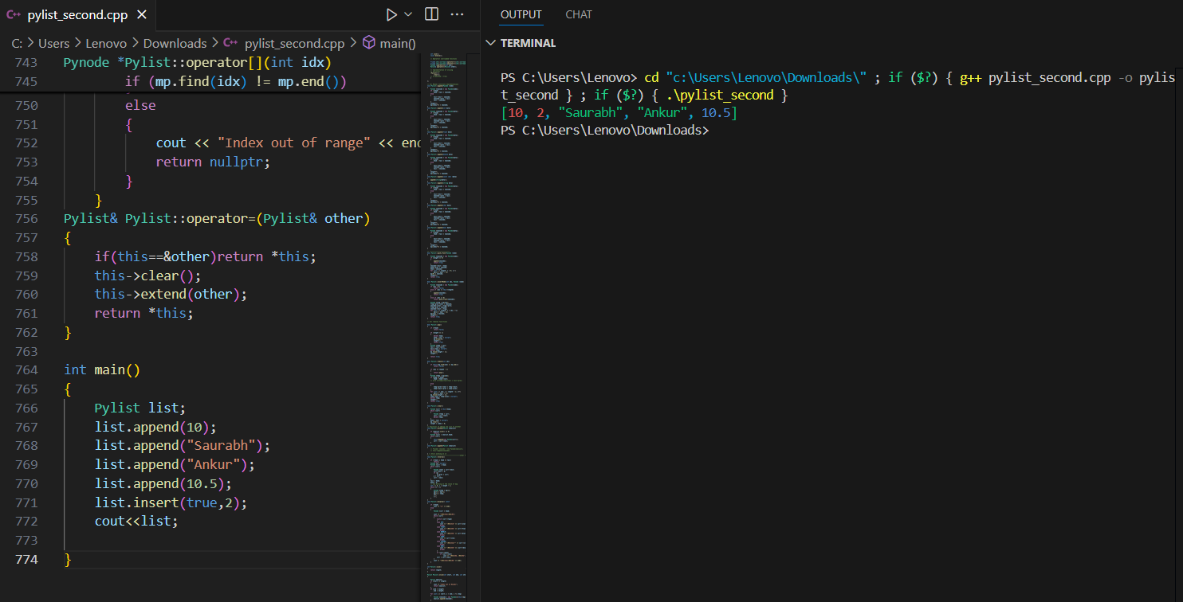

- Output of remove() and pop()
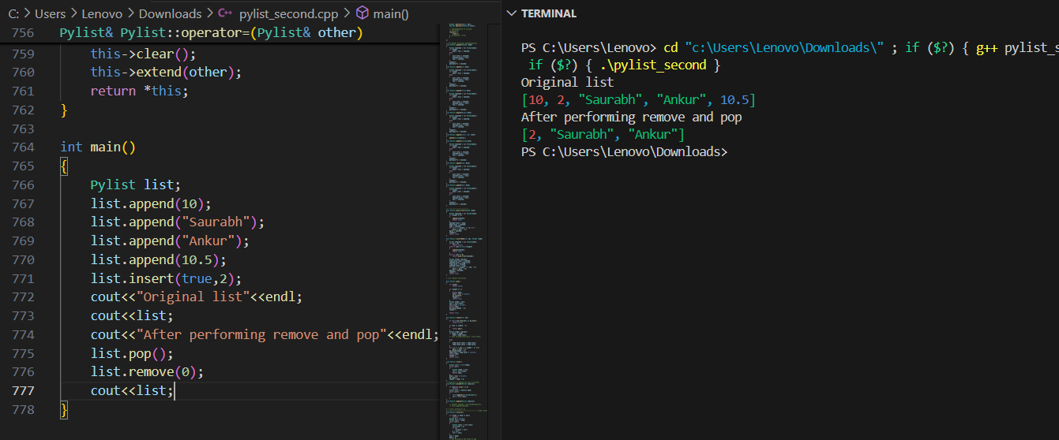

-Output of slice()
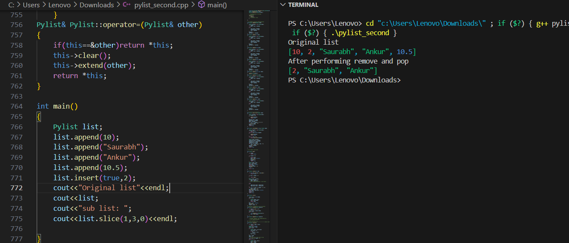

-Output of reverse() and display()
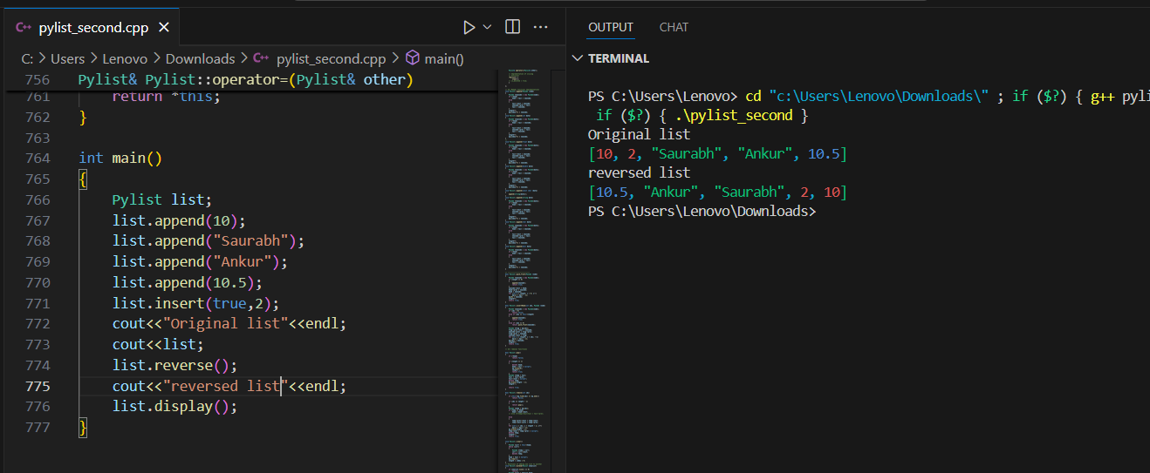

CHAPTER 5: RESULTS AND DISCUSSION

5.1 OUTPUT / REPORT
The final implementation of the Pylist data structure was successfully completed. The class provides dynamic and flexible list-like behavior similar to Python’s built-in list while being implemented in statically-typed C++. The list supports multiple data types including int, float, double, char, bool, and string.
The color-coded terminal output helped to visually distinguish between types, making debugging and testing easier.
All major functionalities were tested including:
- Append and Insert at various positions
- Remove and Pop operations
- Reversing the list
- Slicing with different ranges and steps
- Index-based access with operator overloading

5.2 CHALLENGES FACED
During the course of the project, several technical and conceptual challenges were encountered:
- Handling Multiple Data Types: Managing various types in a statically typed language like C++ was complex. This was handled using constructors, enums, and overloading.
- Memory Management: Dynamically allocating and deallocating memory for each node required careful use of pointers and destructors to avoid memory leaks.
- Implementing Operator Overloading: Replicating Python’s syntactic sugar like [] for indexing and assignment (=) required a solid understanding of operator overloading and pointer manipulation.
- Maintaining Index Map: Ensuring the unordered_map stayed in sync with list operations (like insert, delete, reverse) was tricky and required custom logic after every structural change.

5.3 LEARNINGS
This project proved to be an enriching hands-on learning experience. Some key takeaways include:
- In-depth Understanding of Data Structures: Reinforced concepts like doubly linked lists, dynamic memory handling, and node-based storage.
- C++ Object-Oriented Programming: Gained confidence in using advanced C++ features like constructors, destructors, copy constructors, enums, and friend functions.
- Real-World Problem Solving: Simulating a Python-like behavior in C++ helped bridge the gap between theoretical knowledge and practical implementation.
- Code Modularity and Clean Design: Learned to organize code into reusable, maintainable classes with clear responsibilities and minimal coupling.
- Debugging and Testing: Improved debugging skills through step-wise testing and visually enhanced terminal outputs using ANSI color codes.

CHAPTER 6: CONCLUSION

6.1 SUMMARY
The project titled “Pylist – A Python-like List Implementation in C++” was successfully completed as part of the Summer Training program on Mastering Data Structures and Algorithms offered by Lovely Professional University (LPU).
The goal was to design and implement a flexible, multi-type data structure in C++ that mimics the behavior of Python’s list, allowing storage of different data types like int, float, bool, double, char, and string in a single container. Through careful planning, use of object-oriented programming, and effective memory management techniques, the final implementation achieved this objective.
Key functionalities such as append(), insert(), pop(), remove(), reverse(), and slice() were successfully built and tested. Operator overloading provided a clean interface for accessing elements and assigning values, further enhancing usability.
This project helped reinforce core concepts of data structures, particularly doubly linked lists, and provided valuable exposure to real-world problem solving in C++ programming. It also improved understanding of advanced topics like operator overloading, dynamic memory allocation, and type abstraction using enums.
Overall, the project was a meaningful learning experience, building confidence in both programming and software design, while also demonstrating how Python-like flexibility can be simulated in C++ through thoughtful engineering.

----------------------------------------------THE END------------------------------------------------

